OFFICIAL COORDINATION REQUEST
FOR
NON-ROUTINE OPERATIONS AND MAINTENANCE

COORDINATION TITLE: 13LWG10 AWS Pump #1 Test
COORDINATION DATE: June 10, 2013
PROJECT: Lower Granite Dam

RESPONSE DATE – June 13, 2013

Description of the problem: The Lower Granite project utilizes three auxiliary water supply (AWS) pumps to supply auxiliary water to the adult fishway channel. The project operates with two AWS pumps in service and a third pump held in reserve should a problem develop with one of the operating pumps. The project currently has AWS pumps #2 and #3 operating. AWS pump #1 was recently brought back on line for testing following motor re-wedge work but then failed due to a bad controller card. Consequently the project switched back to operating AWS pumps #2 and #3. AWS pump #1 needs to be brought on line to ensure operational reliability.

Type of outage required: The requested outage would take place on Wednesday, June 26, 2013 from 10:00 am to approximately 11:00 am. After the switch takes place, AWS pump #1 and AWS pump #3 would remain in continuous operation.

Impact on facility operation: Minimal due to a one hour switch-out. AWS pump #3 would remain in operation continuously while the switch out is taking place. AWS pump #2 would be shut down and bulkheads put in place to switch from AWS pump #2 over to AWS pump #1.

Length of time for repairs: The estimated length of time to make the switch should be one hour or less.

Expected impacts on fish passage: Impacts to adult fish passage should be minimal since the planned AWS pump switch will be taking place later in the morning after the main movement of adult fish up the ladder has taken place (see fish passage graph). Currently, over 400 spring Chinook are passing through the ladder each day. Adult steelhead passage through the ladder is presently in the single digits.

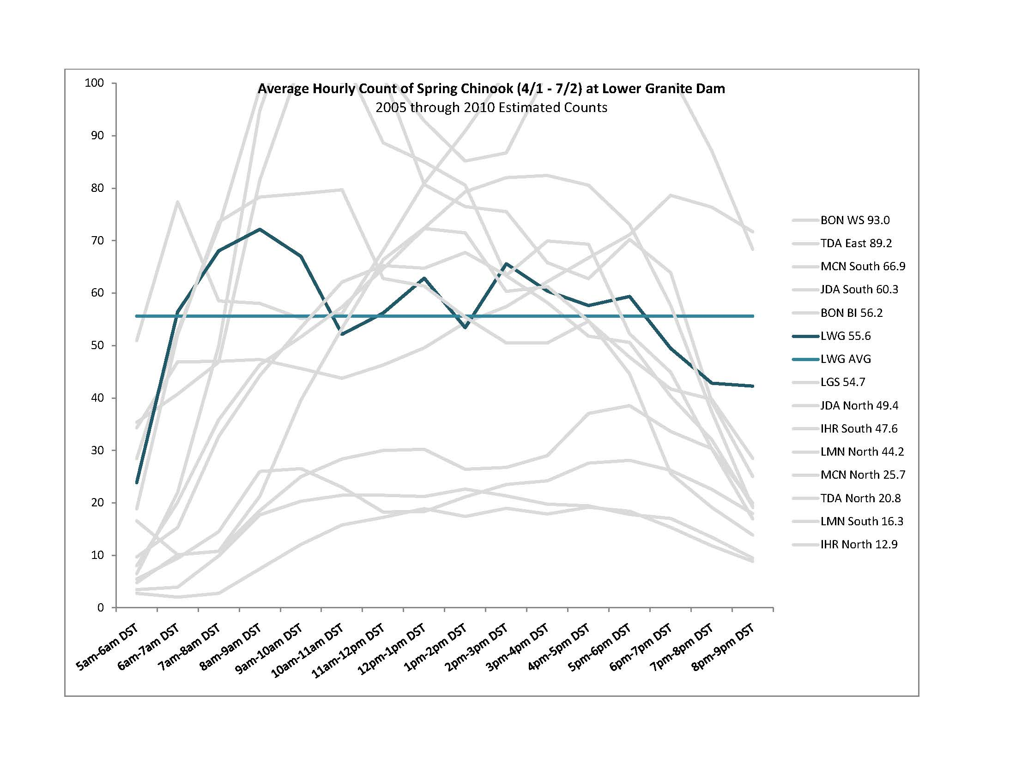
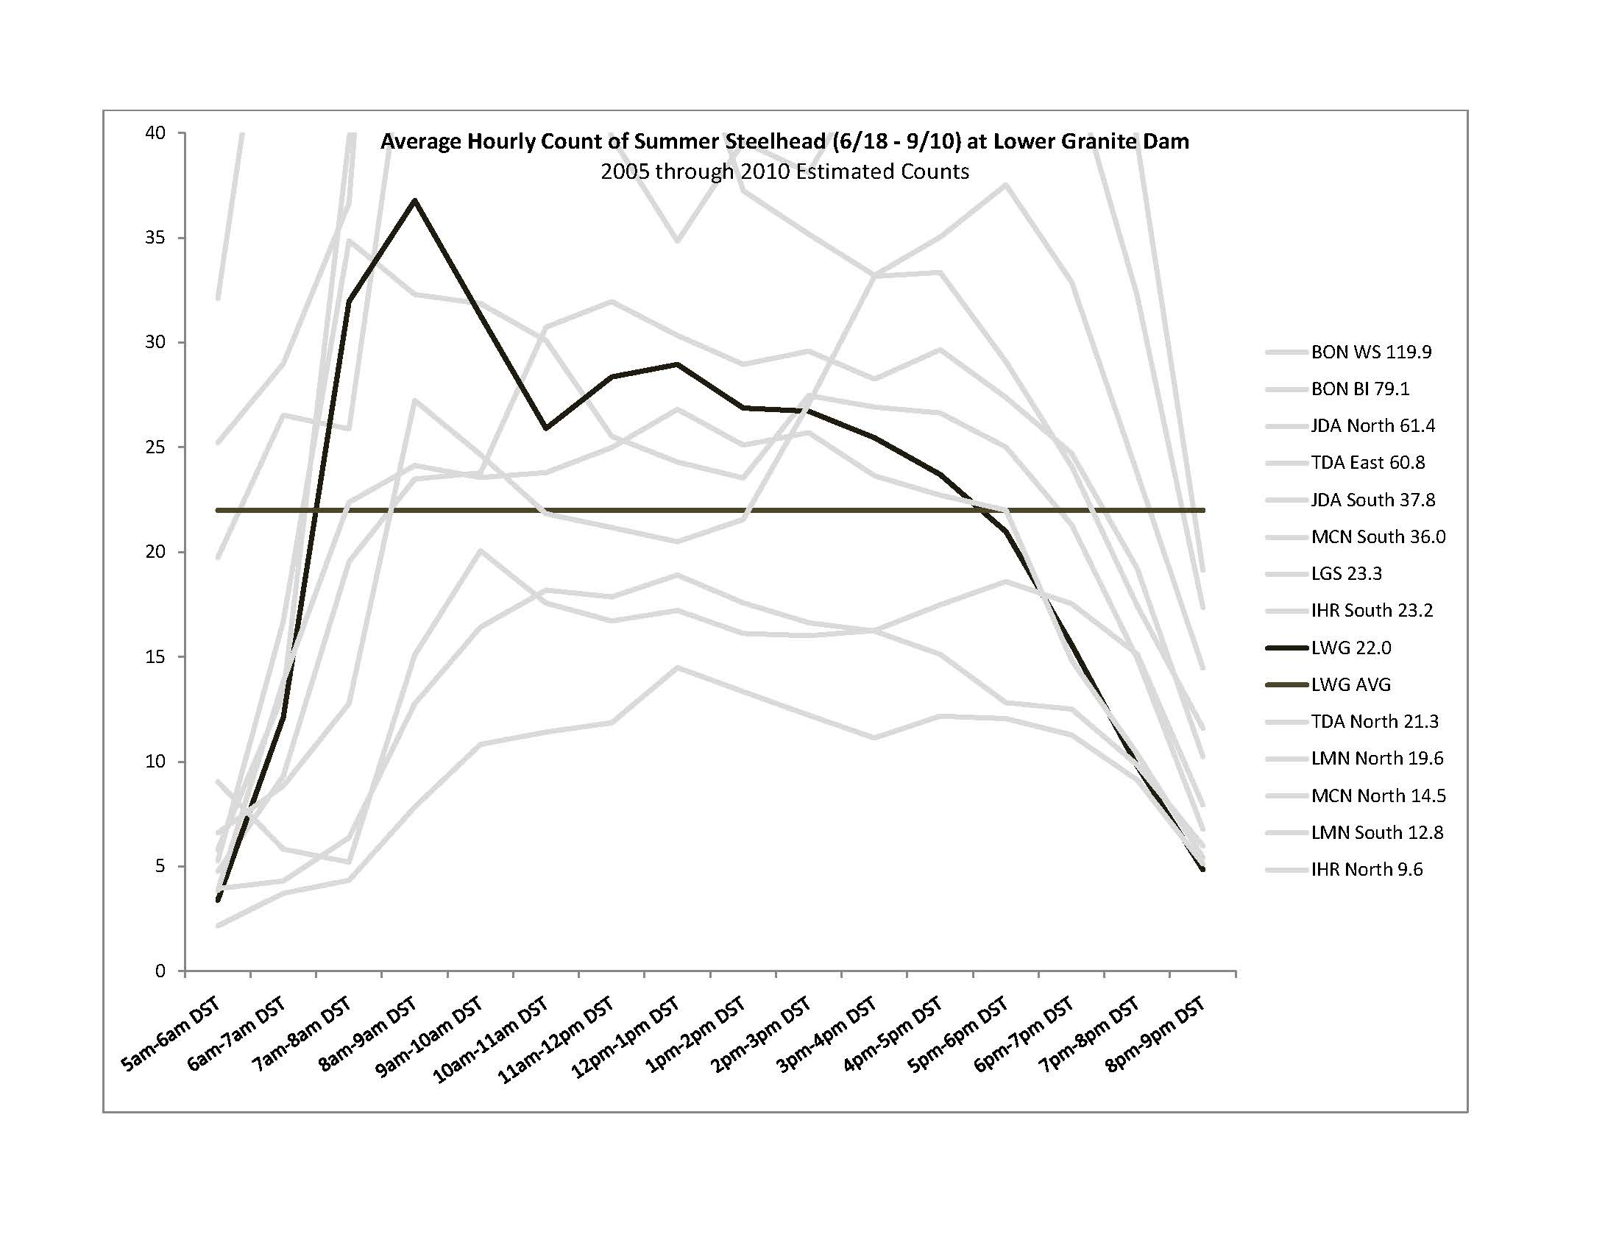
Comments from agencies:

Final results:

Thank you,

Ken Fone, Fishery Biologist
US Army Corps of Engineers
Walla Walla District
Operations Division
201 N. 3rd St
Walla Walla. WA 99362-1876

Phone: (509) 527-7140
Fax: (509) 527-7823
Email: Kenneth.r.fone@usace.army.mil

